Lab Midterm Exam will require you to use SQL Server Management Studio to create and develop a database on Yorktown.

Lab Midterm Exam may contain any (or all) of the skills listed in the bullet points below.

Lab Midterm Exam You may use either SQL commands (in an SQL script) or the Management Studio GUI to complete each task.

The exam will be open-book, open-notes.

The exam is timed. In order to complete the exam in the time allowed, you would do well to practice the bulleted skills multiple times before the exam. You may practice for this exam in SQL Server Management Studio on Yorktown by creating a database named **qYY_ Xm1Practice _YourName**. (where q = quarter: w, s, f; YY = year: 17, 18, 19, 20, and so on.) Example: ***f20_Xm1Practice_Pencil***. Practicing with both the Person spreadsheet and the SisterCity spreadsheet may be helpful.

Note: *MIS 421 Naming Conventions* should be used for any database, table, attribute, or view created.

* Log in to Management Studio using your **WWU network login** credentials.
* Create an empty database (*following simple instructions given on the exam; no preparation is needed.)*
* Import data from an Excel spreadsheet by using the Management Studio Import wizard.
  + Note: The exam spreadsheet may require “preparation” before importing the data.
* Create a table or edit the design of an existing table.
  + Specify the datatype and the data size of attributes.
  + Create an *identity* attribute and set is as the primary key.
  + Set the Allow Nulls value of each field appropriately.
* Create relationships between tables
* Write bulk insert and bulk update statements
* Write select statements
* Create and save a Management Studio ERD for your database.
* Create and save a view. Be prepared for any of these requirements for your view:
  + Show data from a single table.
  + 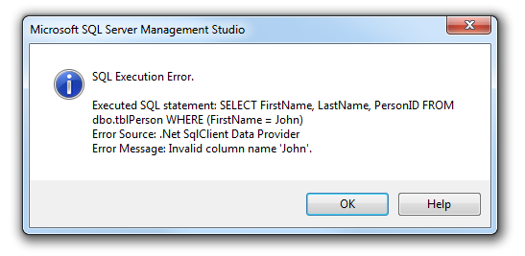Use a WHERE clause to restrict which rows will be returned.
  + Create aliases for a column headings.
  + NOTE: If your *view* has a syntax error (see illustration), you will not be able to save the view in your database. You will see an error message similar to this one:

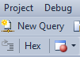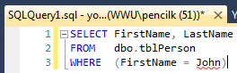Be sure you know how to copy the SELECT statement from the view and paste the SQL code into a “script”:

1. Click “New Query”
2. Paste the SQL code into the **SQLQuery.sql** window.
3. Save the **SQLQuery.sql** window in a convenient location for yourself
4. Finally, upload the **SQLQuery.sql** file to Canvas.